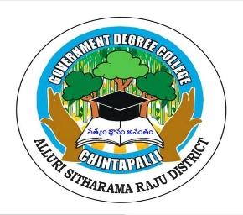
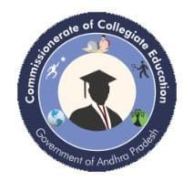
Government Degree College, Chintapalli Affiliated to Andhra University
Chintapalli, Alluri Sitharama Raju -District, AP.
Phone no: 9666739207. Email.lD: qdcchintapalli@qmail.com
Report on Two-Day National Seminar

Title: Intellectual Property Rights: Empowering Innovation and Creativity
Dates: 18–19 August 2025
Organized by: Government Degree College, Chinthapalli
Financial Support: PM-USHA Scheme

Government Degree College, Chinthapalli successfully organized a Two-Day National Seminar on “Intellectual Property Rights: Empowering Innovation and Creativity” on 18th and 19th August 2025. The seminar aimed to promote awareness among academicians, researchers, and students about the significance of Intellectual Property Rights (IPR) in encouraging innovation, protecting creative works, and promoting ethical research practices in higher education. The seminar was organized with financial support from the PM-USHA (Pradhan Mantri Uchchatar Shiksha Abhiyan) Scheme, which enabled the institution to conduct this significant academic programme at the national level.

The seminar was conducted under the esteemed guidance of Chief Patron Dr. Narayana Bharath Gupta, IAS, Director of Collegiate Education, Andhra Pradesh. The programme also received valuable support from Patron Dr. C. Krishna, Joint Director of Collegiate Education, and Co-Patron Dr. P. V. Krishnaji, Regional Joint Director of Collegiate Education (Zones I & II). Their encouragement and administrative support greatly contributed to the successful organization of the seminar.
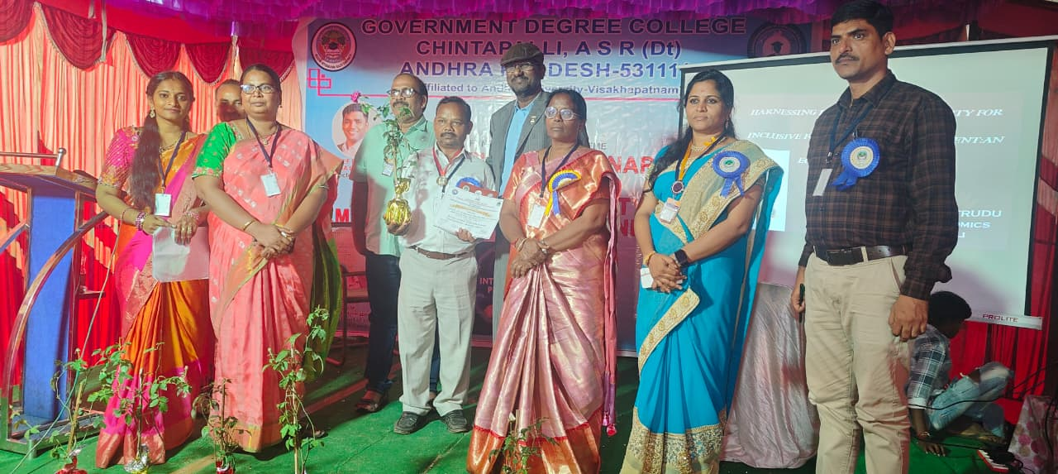
The seminar was presided over by Dr. M. Vijaya Bharathi, Principal of Government Degree College, Chinthapalli, who acted as the President of the Seminar. In her presidential address, she emphasized the growing importance of intellectual property rights in the present knowledge-driven world. She highlighted that protection of intellectual creations is essential to promote innovation, academic integrity, and responsible research among scholars and students.
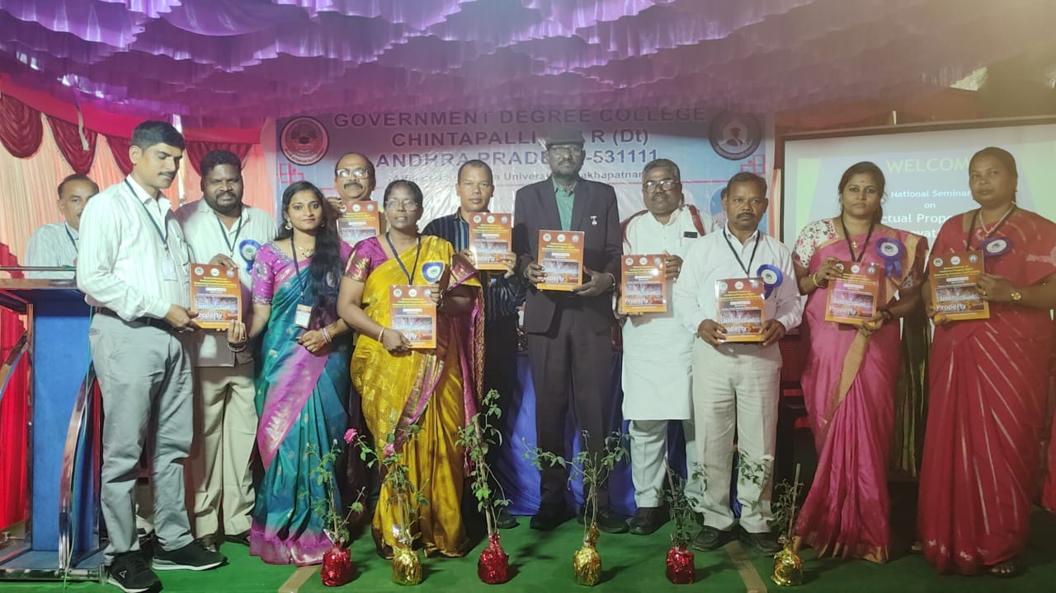
The Keynote Address was delivered by Mr. Y. Babji, Advocate of the High Court of Hyderabad and the Supreme Court of India, who is also the Editor of “Public Relation Voice.” In his keynote speech, he explained the significance of intellectual property rights in protecting original ideas and creative works. He elaborated on different forms of intellectual property such as copyrights, patents, trademarks, and geographical indications, and discussed the legal aspects related to plagiarism, copyright violations, and protection of intellectual works.

The seminar proceedings were enriched by a scholarly Foreword written by Dr. Sharma V. S. Veluri, Former Professor of Kakatiya University, Warangal. In his foreword, he appreciated the initiative taken by Government Degree College, Chinthapalli in organizing a national seminar on such a relevant and contemporary topic. He emphasized that intellectual property rights play a crucial role in safeguarding the creativity of scholars, writers, and innovators.

The seminar volume also included a message from Prof. G. Nanaji Rao, Dean, AU Examination Branch, Andhra University. In his message, he highlighted the importance of intellectual property rights in academic research and stressed the need for maintaining academic integrity and originality in scholarly works.

Another message was contributed by Mr. K. V. Murali Krishna, Retired Lecturer in Chemistry, K. V. College, who appreciated the organizers for selecting an important theme and organizing a national seminar that encourages awareness about intellectual property rights among students and researchers.
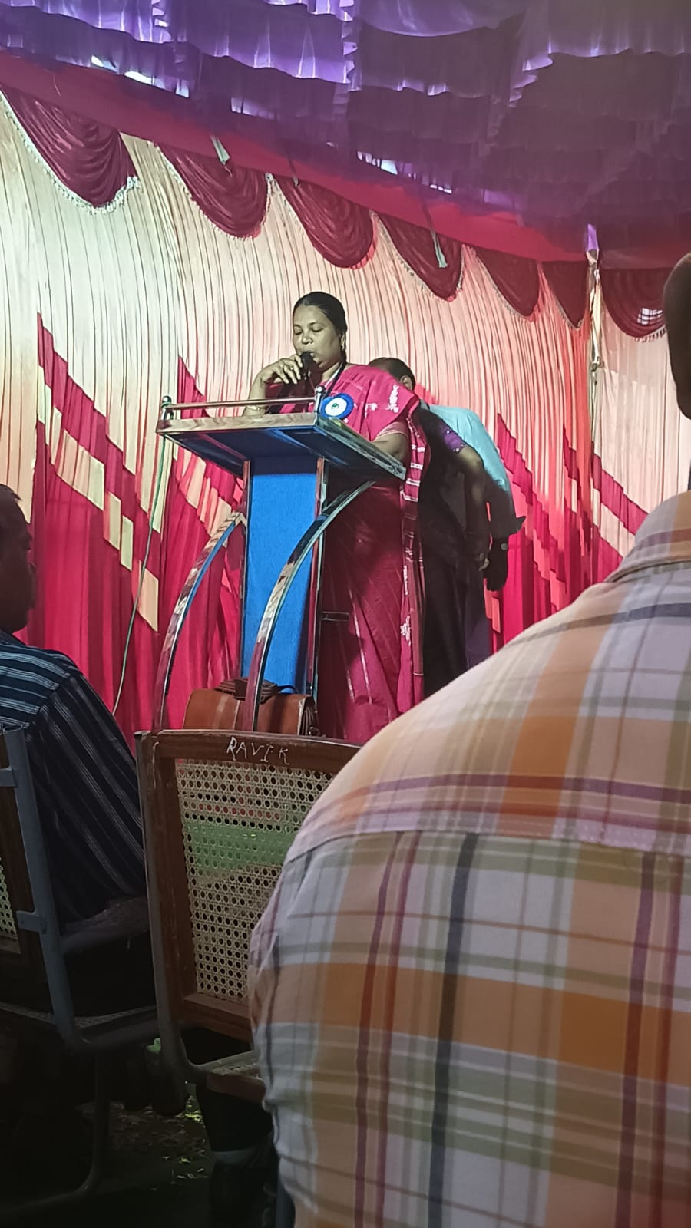
The seminar received an encouraging response from academicians and researchers from different institutions. A total of 54 research papers were received and presented during the technical sessions. The papers addressed various themes related to intellectual property rights, research ethics, copyright in literature, innovation in science and technology, and the role of IPR in academic research. These presentations facilitated fruitful academic discussions and exchange of ideas among scholars.
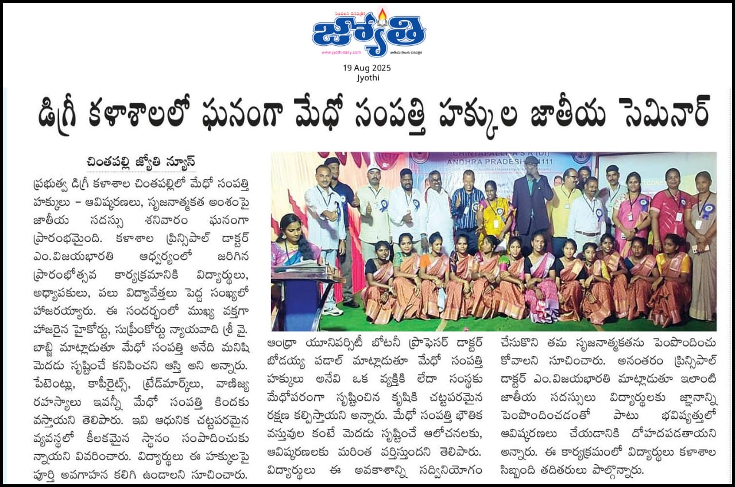
The success of the seminar was made possible by the dedicated efforts of the Editorial Committee and Organizing Committee, whose members worked tirelessly in planning, coordinating, and executing the seminar activities. The committee included Dr. M. Vijaya Bharathi (Principal), Dr. V. Ramana (PM-USHA Coordinator), Dr. M. Srinivasa Patrudu (Vice Principal), K. Leela Pavani (Lecturer in Computer Science), K. Santhoshi (Lecturer in Chemistry), Dr. D. Kejiya (Lecturer in English), and I. Ravindra Naik (Lecturer in Chemistry). Their sincere commitment, teamwork, and meticulous planning ensured the smooth conduct of the seminar and the successful publication of the seminar proceedings. The organizing members deserve special appreciation for their tireless efforts and coordination in making the seminar a grand academic success.

The two-day national seminar concluded with meaningful academic deliberations and valuable insights into the role of intellectual property rights in fostering innovation and creativity. The event successfully created awareness among participants about the importance of protecting intellectual work and encouraged scholars and students to contribute responsibly to knowledge creation. Overall, the seminar proved to be a significant academic initiative that strengthened scholarly interaction and promoted awareness of intellectual property rights in higher education.

